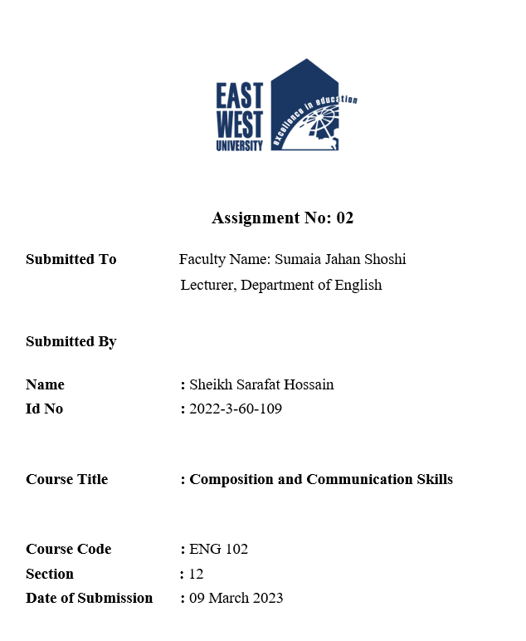
International Language Day as a fresher
At my university
Outline:
Thesis statement: As a fresher at my university, I had the opportunity to observe this day, which was an enlightening experience. This day reminds me about the history and sacrifice of 1952 which made us proud.
Body paragraph 1:
Topic sentence: On 21st February 1952, students and activists in East Pakistan (now Bangladesh) protested the Pakistani Government’s decision to impose Urdu as official language of the country.
- History of mother language day
- Sacrifice of language martyrs
- Building Shahid Minar
Body paragraph 2:
Topic sentence: This day provides an opportunity to recognize the importance of preserving linguistic diversity and the role of language in promoting global citizenship.
- Significance of 21st February.
- UNESCO declared this day as international mother language day in 1999.
Body paragraph 3:
Topic sentence: The preparation for celebration of the day started a week earlier.
- Students making banner and poster.
- Dressed white & black saree / Panjabi.
- Seminar and speeches were arranged.
- The chief speaker talked about importance of the day.
Conclusion:
Concluding sentence: International mother language day is a significant event that reflects the diversity and multilingualism. As a fresher at my university, I had the opportunity to observe this day and witness the beauty of different languages and cultures. It was an enriching experience that has left a lasting impression on me.

International Language Day is celebrated worldwide on 21st February every year to promote linguistic diversity and multilingualism. As a fresher at my university, I had the opportunity to observe this day, which was an enlightening experience. This day reminds us the history, sacrifice of 1952 which made us proud.
On February 21, 1952, students and activists in East Pakistan (Now Bangladesh) protested the Pakistani government's decision to impose Urdu as the only official language of the country. During the protest, police opened fire on the demonstrators, killing several of them. This is one and only sacrifice of lives for the sake of the Mother Language in the history of mankind.
This day provides an opportunity to recognize the importance of preserving linguistic diversity and the role of language in promoting global citizenship, cultural exchange, and mutual understanding. It is a reminder that every language has its unique value, and each language deserves to be respected and celebrated. 21 February was declared to be International Mother Language Day by UNESCO in 1999. The declaration came up in tribute to the Language Movement done by the Bangladeshis.
The preparations for the day started a week earlier. Various student from the cultural club took the initiative to arrange programs to celebrate the day. There were poetry recitation competitions and cultural exhibitions. The university administration also organized seminars and lectures on the importance of language learning. On the day itself, the university was bustling with excitement. Everyone mourns by wearing black clothes. The main event was held in our new auditorium, where students from different departments, cultures and languages gathered to celebrate the day. The event started with the national anthem. Then the chief speaker talked about importance of the day
As a student, I felt proud and honored to be a part of such a multicultural community. It was an eye-opening experience to witness the beauty and richness of different languages and cultures. The event helped me understand the importance of preserving and promoting linguistic diversity in our society.
To wrap things up, International Language Day is a significant event that reflects the diversity and multilingualism. As a fresher at my university, I had the opportunity to observe this day and witness the beauty of different languages and cultures. It was an enriching experience that has left a lasting impression on me.

